**How can electricity cause magnetism?**

**Description:** Students will build a simple electromagnet and examine devices that utilize electromagnets to make things move.

**California State Standard(s): SC.4.1.c. Students know electric currents produce magnetic fields and know how to build a simple electromagnet. SC.4.1.d. Students know the role of electromagnets in the construction of electric motors, electric generators, and simple devices, such as doorbells and earphones.**

|  |  |
| --- | --- |
| **Student Materials (per group)** | **Additional Teacher Materials:** |
| * 50 cm of wire | * Doorbell |
| * 1 iron nail | * Generator |
| * 1 C or D battery | * Motor |
| * 1 box of paperclips | * Earphones |

For the additional materials it is suggested that actual items be used, but pictures may also be used. It is helpful because you will be able to explore the inside of the objects and allow students examine the electromagnets found within.

|  |
| --- |
| **Background and Misconceptions:** |

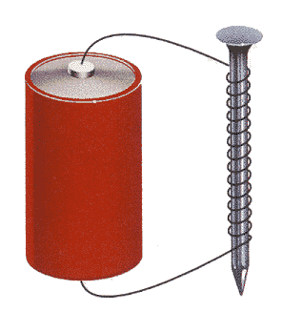

Electromagnets utilize a simple rule of electricity: The flow of electricity can create a magnetic field, and a moving magnetic field causes electricity to flow. This simple interaction of electricity is what causes an electromagnet to operate. As electricity flows out of a battery through wires, a magnetic field is formed. The strength of the magnetic field is amplified by wrapping the wire around an iron nail. The more turns of wire, the greater the magnetic effect. The magnetism only lasts while electrons are flowing through the wire.

This helpful interaction is what allows engineers to build objects like electric motors, generators, doorbells, and earphones. In each case, the interaction between electricity and magnetism is utilized to cause motion. Inside of an **electric generator**, an outside power source is used to move an arm that is connect to a moveable magnet. In the picture below, this magnet is seen connected to the 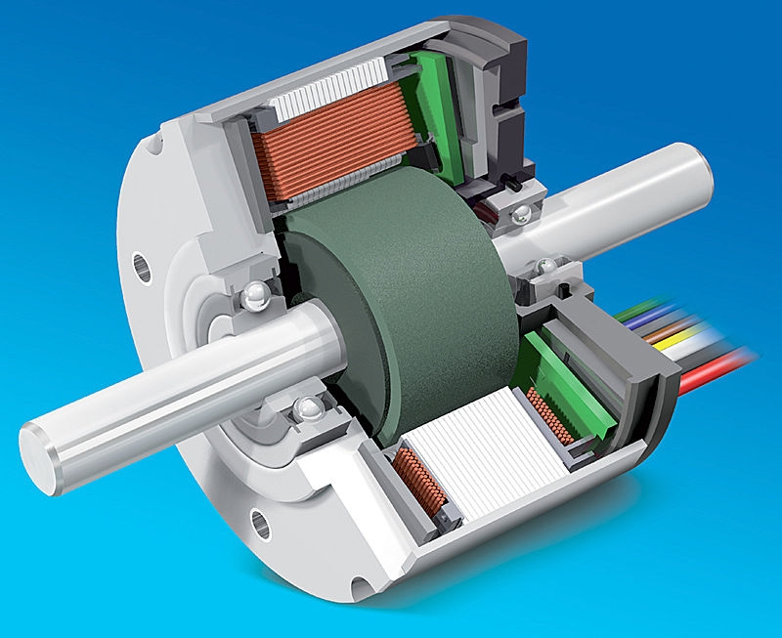arm in the core. As the magnet moves past the wires that are in a ring surrounding the core, electricity starts to flow. (The outside power source can be anything! It can be moving water, steam from a coal or nuclear power plant, or wind pushing on the blades of a turbine.)

An **electric motor** is exactly the opposite of an electric generator. It is just operating in reverse. Instead of the outside energy moving the magnet, electricity flows into the wires, creating a magnetic field, and the magnet then moves in response to it.

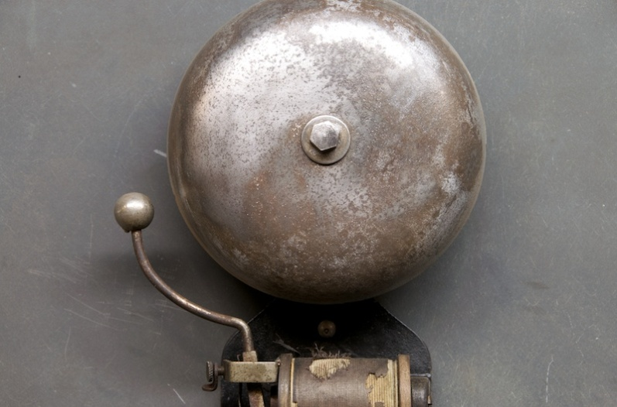A doorbell is an application of the motor. As the electricity moves into the motor, the magnet moves. But in this case, the magnet has a lever arm attached to it. The magnet and arm move back and forth causing the hammer to strike the bell. The motion back and forth is a result of oscillating electricity. Electricity can either flow all in one direction (called DC or Direct Current electricity) or it can move back and forth (called AC or alternating current.) The doorbell hammer vibrates back and forth because of AC electricity.

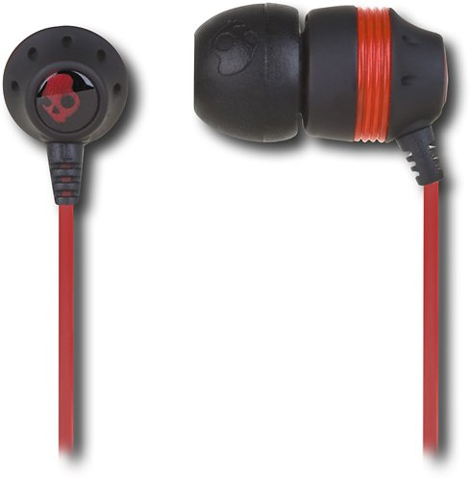Vibrating electricity and vibrating magnets may be common to students. When they think about what causes sound, they should know that sound is a result of vibrations. To reproduce sound in a speaker, the electricity is varying its strength and direction. The electrical current causes the interaction between a coil of wires and the magnet to create vibrations. These vibrations push the speaker cone and the sound is reproduced.

Electromagnets and the interaction between electricity and magnetism is what cause motion. The motion can be used to pick up paperclips, move a motor arm or recreate sound.

|  |
| --- |
| **Teacher Guided Questions to Inquiry:** ***Use these questions to get the students started on their own inquiry!*** |

1. What is an electromagnet?
2. What are uses for electromagnets?
3. What creates magnetism?
4. How can electricity flowing through a wire be used to create magnetism?
5. What do you need to do to make the strongest electromagnet?
6. What devices use electromagnets or interactions between electricity and magnetism?

|  |
| --- |
| **Additional Hints:** |

* When using the battery, monitor to ensure the batteries do not overheat.
* If you have the resources, allow students to deconstruct a motor, generator, doorbell, and earphones so they can examine the electromagnets found within.

**TEACHER ANSWER KEY**

**How Can Electricity Cause Magnetism?**

**Name _____________________________**

**Date ____________________**

**Description:** When electricity moves through a wire, it turns the wire into a magnet. The magnet is not very strong so using a nail and looping the wire around the nail will help make it stronger.

In this lab, you are going to find out how to make a magnet using electricity and how to make it stronger. What you are making is called an ELECTROMAGNET.

**Materials:** 50 cm of wire 1 iron nail

1 C or D battery 1 box of paperclips

**Procedures:**

1. Wrap the wire around the nail 10 times. This will leave a large part of the wire unwrapped.
2. Connect the battery to the wires. One end of the wire will be connected to the + side of the battery and the other end of the wire will connect to the – side of the battery. (Look on the battery for the + and – marks)
3. Bring the end of the nail near paper clips. How many are picked up? Write the number picked up in the table below.
4. Wind the wire around the nail 10 more times. The nail will be wrapped with wire 20 times. Try to pick up the paper clips. Write down the number picked up in the table below.
5. Repeat this for other amounts that you pick. How can you pick up more paper clips?

|  |  |  |  |  |  |
| --- | --- | --- | --- | --- | --- |
| Number of times nail is wrapped | 10 | 20 | Students answer will vary, but in general, as more wire is wrapped around the iron, more paper clips will be picked up. |  |  |
| Number of paperclips picked up | 5 | 7 |  |  |  |

**Extension:**

Electromagnets are used in a variety of home devices. Your teacher will have on display the following items. Write in the box below how an electromagnet is used in each device.

|  |  |  |
| --- | --- | --- |
| Device |  | How is an electromagnetic used? |
| Earphones | http://rds.yahoo.com/_ylt=A0S020pEG1tMJV8Ap.WjzbkF/SIG=12drl01ud/EXP=1281125572/**http%3a/ecx.images-amazon.com/images/I/41wqdJvk%252BCL.jpg | There is a small magnet in each earbud and a coil of wire. The electricity moving through the wire causes the magnet to move. The magnet is attached to the speaker cone. The speaker cone moves, producing sound. |
| Motor | http://rds.yahoo.com/_ylt=A0S020mLG1tMGAYAH2GjzbkF/SIG=13aqtqdgo/EXP=1281125643/**http%3a/img.directindustry.com/images_di/photo-g/brushless-dc-electric-motor-322189.jpg | Electricity moves through the wire, causing the magnet attached to the arm to start to move. The motor arm will spin. |
| Generator | http://rds.yahoo.com/_ylt=A0S020kwHFtMyhIArJKjzbkF/SIG=122k762el/EXP=1281125808/**http%3a/www.washjeff.edu/capl/images/l/1292.jpg | A magnet is moved past a set of wires, causing electricity to move in the wires. This is what is used to produce electricity. |
| Doorbell | http://rds.yahoo.com/_ylt=A0S020niHFtMuhMAeIajzbkF/SIG=13e1otavg/EXP=1281125986/**http%3a/www.factory20.com/files/gimgs/1100_1731vintage-early-electric-arlarm-wall-bell1.jpg | When the doorbell is pushed, a circuit is completed, and electricity moves through the wire causing the magnet attached to the arm with the ball to vibrate back and forth. |

Images: <http://ecx.images-amazon.com/images/I/41wqdJvk%2BCL.jpg>

<http://img.directindustry.com/images_di/photo-g/brushless-dc-electric-motor-322189.jpg>

<http://www.washjeff.edu/capl/images/l/1292.jpg>

[**http://www.factory20.com/files/gimgs/1100_1731vintage-early-electric-arlarm-wall-bell1.jpg**](http://www.factory20.com/files/gimgs/1100_1731vintage-early-electric-arlarm-wall-bell1.jpg)

**Questions:**

1. How does the number of times you wrap the nail with wire change the number of paper clips that are picked up?

**The more times the nail is wrapped, the more paper clips that are picked up.**

1. What travels through the wire when you connect the two ends of the wire to the battery?

**Electricity. The electricity is the flow of charge through the circuit.**

1. Electricity is flowing through the wires from the battery. When electricity travels through a wire, what else does it do?

**It creates a magnetic field that can be used to move things.**

1. How are electromagnets used in various types of devices?

The electromagnets are used to make things move. In each of the examples in this activity, by using an electromagnet, something turns or moves.

**How Can Electricity Cause Magnetism?**

**Name _____________________________**

**Date ____________________**

**Description:** When electricity moves through a wire, it turns the wire into a magnet. The magnet is not very strong so using a nail and looping the wire around the nail will help make it stronger.

In this lab, you are going to find out how to make a magnet using electricity and how to make it stronger. What you are making is called an ELECTROMAGNET.

**Materials:** 50 cm of wire 1 iron nail

1 C or D battery 1 box of paperclips

**Procedures:**

1. Wrap the wire around the nail 10 times. This will leave a large part of the wire unwrapped.
2. Connect the battery to the wires. One end of the wire will be connected to the + side of the battery and the other end of the wire will connect to the – side of the battery. (Look on the battery for the + and – marks)
3. Bring the end of the nail near paper clips. How many are picked up? Write the number picked up in the table below.
4. Wind the wire around the nail 10 more times. The nail will be wrapped with wire 20 times. Try to pick up the paper clips. Write down the number picked up in the table below.
5. Repeat this for other amounts that you pick. How can you pick up more paper clips?

|  |  |  |  |  |  |
| --- | --- | --- | --- | --- | --- |
| Number of times nail is wrapped | 10 | 20 |  |  |  |
| Number of paperclips picked up |  |  |  |  |  |

**Extension:**

Electromagnets are used in a variety of home devices. Your teacher will have on display the following items. Write in the box below how an electromagnet is used in each device.

|  |  |  |
| --- | --- | --- |
| Device |  | How is an electromagnetic used? |
| Earphones | http://rds.yahoo.com/_ylt=A0S020pEG1tMJV8Ap.WjzbkF/SIG=12drl01ud/EXP=1281125572/**http%3a/ecx.images-amazon.com/images/I/41wqdJvk%252BCL.jpg |  |
| Motor | http://rds.yahoo.com/_ylt=A0S020mLG1tMGAYAH2GjzbkF/SIG=13aqtqdgo/EXP=1281125643/**http%3a/img.directindustry.com/images_di/photo-g/brushless-dc-electric-motor-322189.jpg |  |
| Generator | http://rds.yahoo.com/_ylt=A0S020kwHFtMyhIArJKjzbkF/SIG=122k762el/EXP=1281125808/**http%3a/www.washjeff.edu/capl/images/l/1292.jpg |  |
| Doorbell | http://rds.yahoo.com/_ylt=A0S020niHFtMuhMAeIajzbkF/SIG=13e1otavg/EXP=1281125986/**http%3a/www.factory20.com/files/gimgs/1100_1731vintage-early-electric-arlarm-wall-bell1.jpg |  |

Images: <http://ecx.images-amazon.com/images/I/41wqdJvk%2BCL.jpg>

<http://img.directindustry.com/images_di/photo-g/brushless-dc-electric-motor-322189.jpg>

<http://www.washjeff.edu/capl/images/l/1292.jpg>

[**http://www.factory20.com/files/gimgs/1100_1731vintage-early-electric-arlarm-wall-bell1.jpg**](http://www.factory20.com/files/gimgs/1100_1731vintage-early-electric-arlarm-wall-bell1.jpg)

**Questions:**

1. How does the number of times you wrap the nail with wire change the number of paper clips that are picked up?
2. What travels through the wire when you connect the two ends of the wire to the battery?
3. Electricity is flowing through the wires from the battery. When electricity travels through a wire, what else does it do?
4. How are electromagnets used in various types of devices?